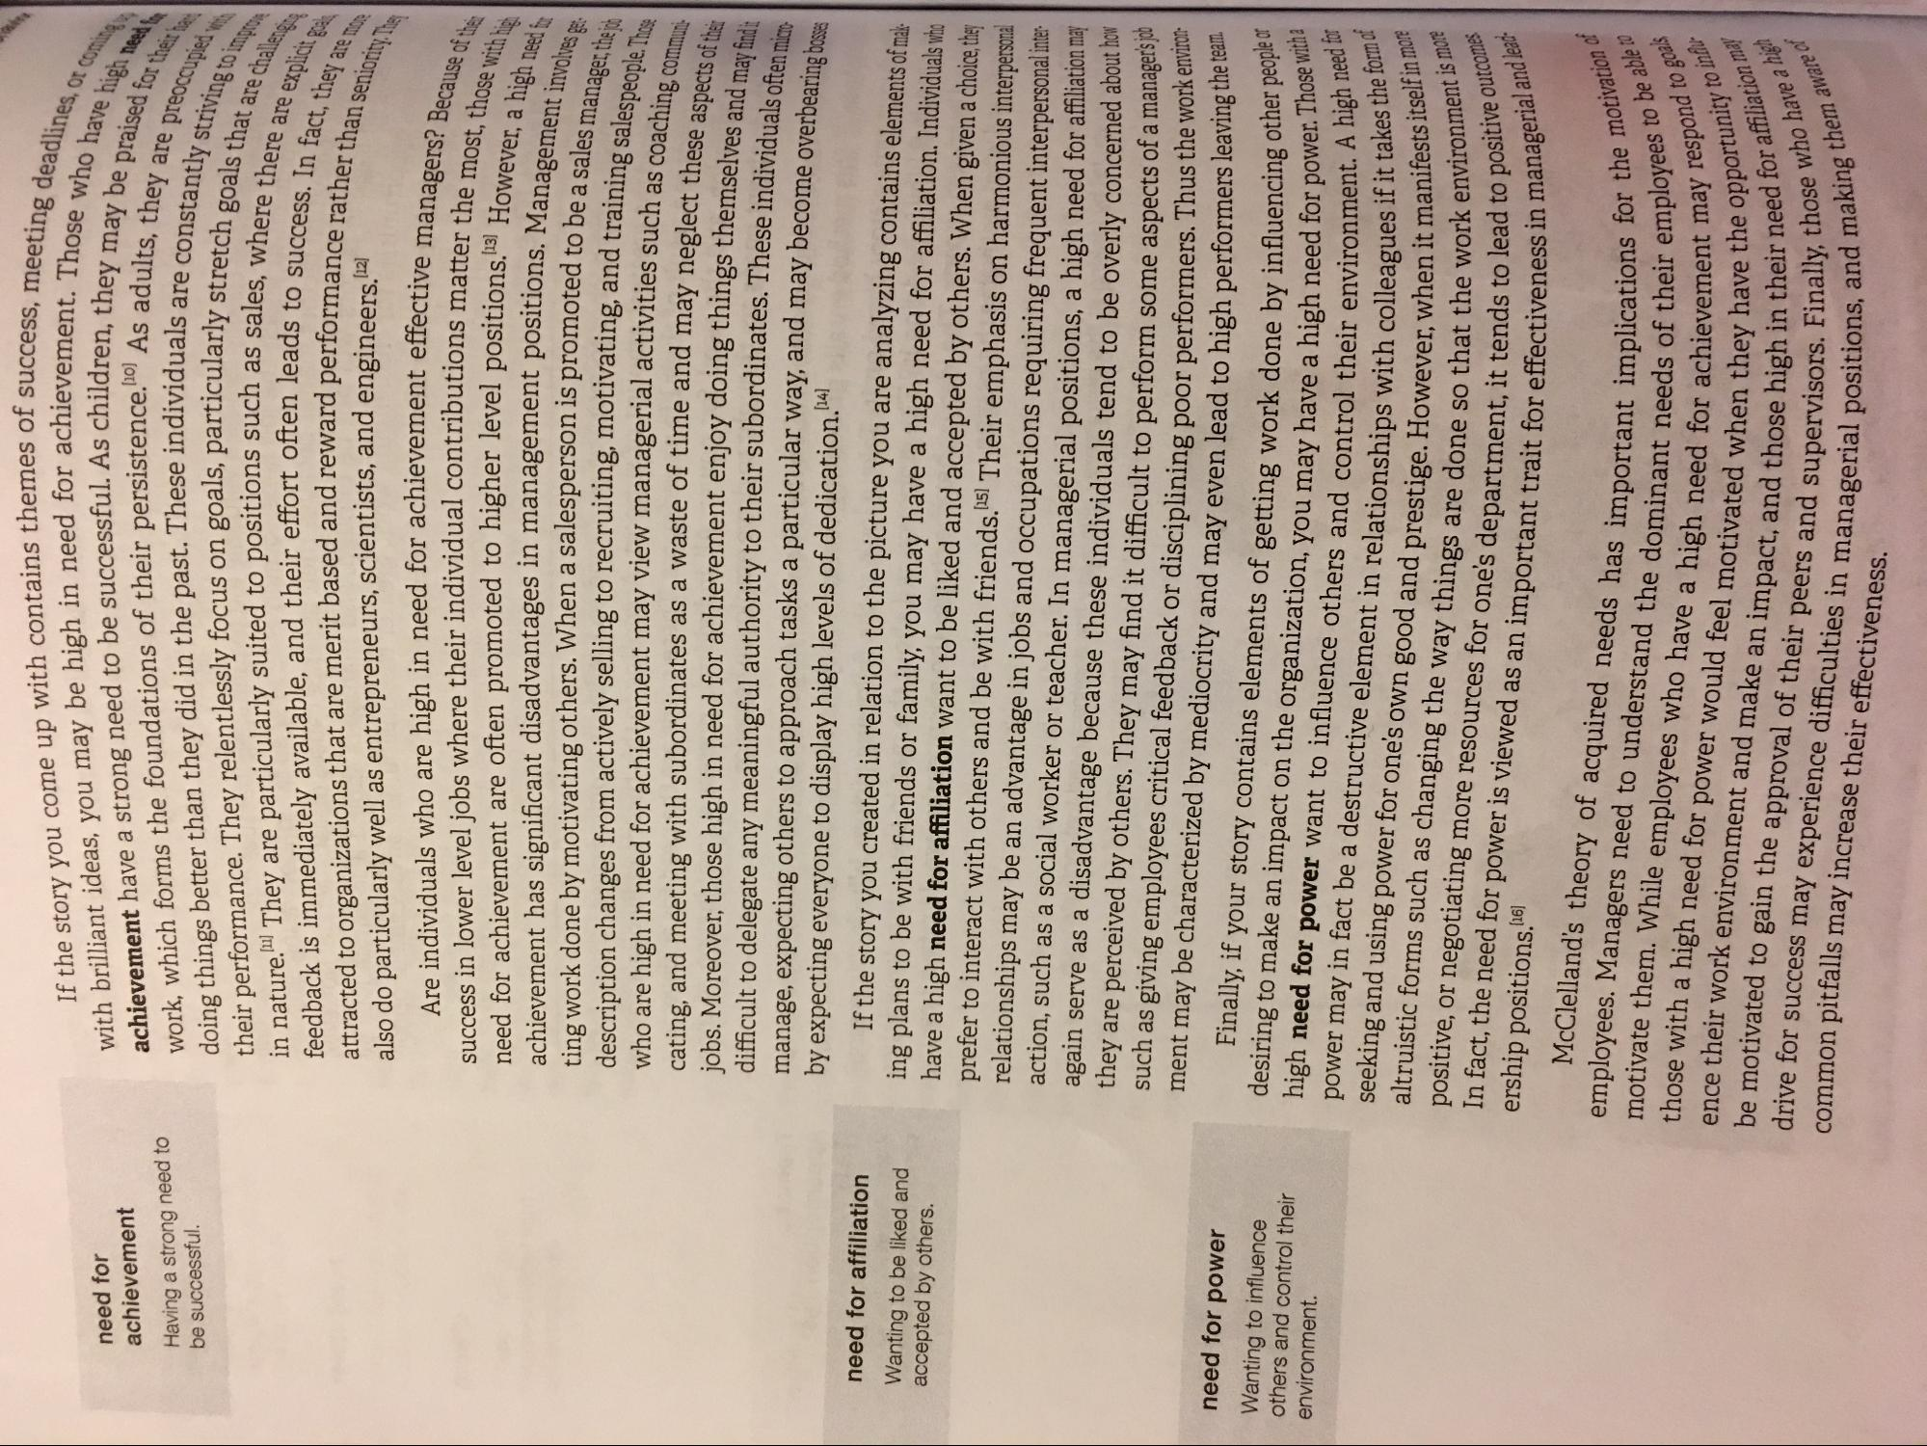
deadlines, or com
need for achievement Having a strong need to be successful.
have high need
vement. Those who have hi ren, they may be praised for
As adults, they are preoccun viduals are constantly striving
ly stretch goals that are chal
les, where there are explici eads to success. In fact, they
nance rather than seniority
are challenge
are explicit Bali
fact, they are more
If the story you come up with contains themes of
contains themes of success, meeting des with brilliant ideas, you may be high in need for achievement achievement have a strong need to be successful. As children the work, which forms the foundations of their persistence.110) As ad doing things better than they did in the past. These individuals ar their performance. They relentlessly focus on goals, particularly in nature. They are particularly suited to positions such as sales feedback is immediately available, and their effort often leads to attracted to organizations that are merit based and reward performand also do particularly well as entrepreneurs, scientists, and engineers [12]
Are individuals who are high in need for achievement effective me success in lower level jobs where their individual contributions matter need for achievement are often promoted to higher level positions [13] achievement has significant disadvantages in management positions More ting work done by motivating others. When a salesperson is promoted to be a com description changes from actively selling to recruiting, motivating, and training who are high in need for achievement may view managerial activities such as cating, and meeting with subordinates as a waste of time and may neglect these jobs. Moreover, those high in need for achievement enjoy doing things themselves an difficult to delegate any meaningful authority to their subordinates. These individuals of manage, expecting others to approach tasks a particular way, and may become overbearing by expecting everyone to display high levels of dedication.14]
tive managers? Because of the matter the most, those with his
[13] However, a high needs ins Management involves get
to be a sales manager, the job d training salespeople. Those
such as coaching, commun: av neglect these aspects of their
is themselves and may find it
n micut
need for affiliation
Wanting to be liked and accepted by others.
r's job environ
need for power Wanting to influence others and control their environment.
If the story you created in relation to the picture you are analyzing contains elements of mala ing plans to be with friends or family, you may have a high need for affiliation. Individuals who have a high need for affiliation want to be liked and accepted by others. When given a choice, they prefer to interact with others and be with friends.[5] Their emphasis on harmonious interpersonal relationships may be an advantage in jobs and occupations requiring frequent interpersonal interaction, such as a social worker or teacher. In managerial positions, a high need for affiliation may again serve as a disadvantage because these individuals tend to be overly concerned about how they are perceived by others. They may find it difficult to perform some aspects of a manage such as giving employees critical feedback or disciplining poor performers. Thus the work ment may be characterized by mediocrity and may even lead to high performers leaving
Finally, if your story contains elements of getting work done by influencing on desiring to make an impact on the organization, you may have a high need for power high need for power want to influence others and control their environment. power may in fact be a destructive element in relationships with colleagues til seeking and using power for one's own good and prestige. However, when it m altruistic forms such as changing the way things are done so that the work ership positions.16) positive, or negotiating more resources for one's department, it tends to In fact, the need for power is viewed as an important trait for effectiveness
need for power. Those with a ir environment. A high need for
form of
r, when it manifests itself in more
the work environment is more
to positive outcomes managerial and lead
ness inn
otivation of
implications for the motivation
f their employees to be able evement may respond to goa
oportunity to influ
or affiliation may
McClelland's theory of acquired needs has important implicatio employees. Managers need to understand the dominant needs of the motivate them. While employees who have a high need for achievement those with a high need for power would feel motivated when they have ence their work environment and make an impact, and those high in be motivated to gain the approval of their peers and supervisors. common pitfalls may increase their effectiveness. drive for success may experience difficulties in managerial positions,
gh in their need for affiliation
Finally, those who have a sitions, and making them aw
em aware of

